SOCCERTON
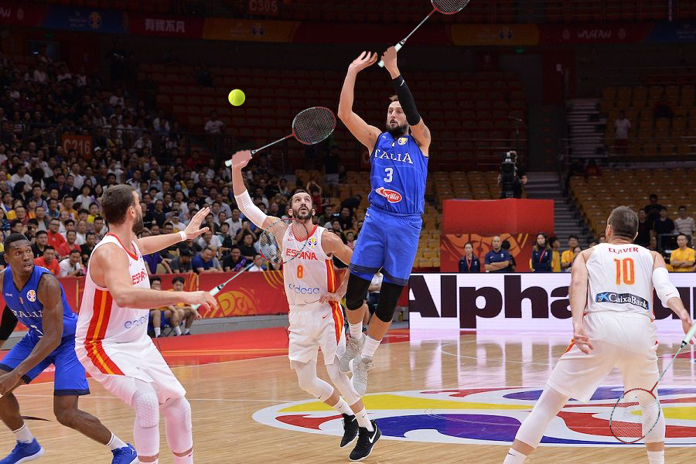

Soccerton is a mix of soccer and badminton. It is played in a basketball field with soccer goals. In front of the football goals (3mt in front) there is an area where only the goalkeepr can stay in. Soccerton is played with badminton rackets and a soft ball or tennis ball. At the end the team with the major numbers of goals is the winner.
RULES
- The 2 teams are composed by 6 players, 5 players and 1 goalkeeper.
- The match begins by playing rock, paper, scissor or by throwing a coin for deciding which team plays first.
- The first shot is played by the goalkeeper of the team that won rock,paper,scissor. The shot can not overshoot the half of the field. In case of overshoot the ball must be played by the goalkeepr of the other team.
- The teams that is attacking can hit the ball only from the bottom and not from the top. The team that is defending can hit the ball in any way.
- In case of dangerous game the player must be out of the game for 3 minutes. Dangerous game is decided by the referee.
- If the balli s in the area the goalkeeper can take it with the hands. The shot must be done with racket and can’t overshoot the half of the field. In case of overshoot refer to rule 4.
- In case of equality at the end of the firts 2 stages, the match continues with another 2 stages of 5 minutes each. If the score is the same even at the end of the extra time the match will continue with golden goal. The first match to score a point is the winner.

TIMES
The match is composed by 2 stages of 15 minutes each. In case of same score at the end of the 30 minutes, the extra time is composed by 2 stages of 5 minutes each.

